¡Vamos a crear un “Meme”!
¿Qué es un “meme”?
- a humorous image, video, piece of text, etc., that is copied (often with slight variations) and spread rapidly by Internet users.

This homework assignment is simple. Just choose a stem-changing verb from class (“verbo de cambio radical”, o “verbo de bota”) and create a meme with it. Usually memes contain just a phrase or sentence, with a funny picture.

. 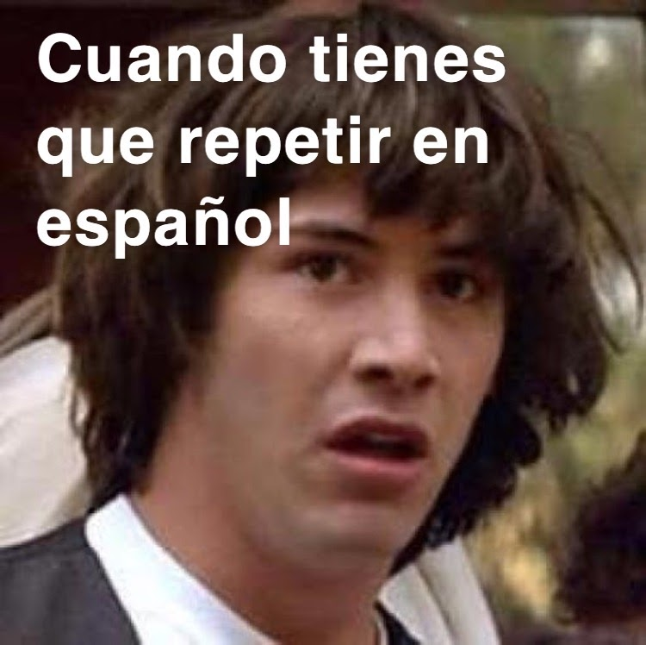

¡Vamos a crear un “Meme”!
¿Qué es un “meme”?
- a humorous image, video, piece of text, etc., that is copied (often with slight variations) and spread rapidly by Internet users.

This homework assignment is simple. Just choose a stem-changing verb from class (“verbo de cambio radical”, o “verbo de bota”) and create a meme with it. Usually memes contain just a phrase or sentence, with a funny picture.

